Biden arrives in Britain ahead of NATO summit, Finland visit
https://news.yahoo.com/biden-leaves-uk-nato-summit-195054501.html

- 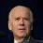
AFP
Sun, July 9, 2023 at 2:27 PM MST·3 min read
In this article:

- 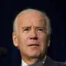
Joe Biden
46th and current president of the United States
Jill Biden
American educator and First Lady of the United States
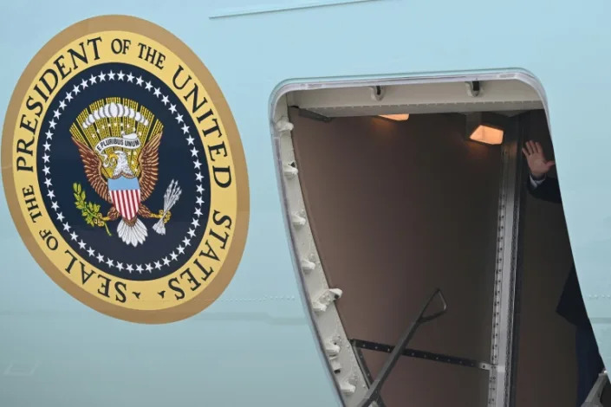
US President Joe Biden waves while boarding Air Force One at Dover Air Force Base in Dover, Delaware, on July 9, 2023 en route to a meeting with King Charles III in England, before attending a NATO summit in Lithuania and then visiting Finland (ANDREW CABALLERO-REYNOLDS)
President Joe Biden arrived in Britain Sunday where he will meet King Charles III and Prime Minister Rishi Sunak before continuing to Vilnius for a NATO summit, then a final stop in new NATO member Finland.
Air Force One touched down at Stansted Airport north of London late in the evening, an AFP journalist reported.
On Monday, he meets the British monarch at Windsor Castle, one of the royal residences, for the first time since Charles III's coronation.
The US president did not attend the ceremony, sending First Lady Jill Biden instead.
Their talks are expected to focus on environmental issues, the White House said.
Biden will also be meeting with Sunak at 10 Downing Street.
The main part of Biden's Europe trip will be the NATO summit in the Lithuanian capital Tuesday and Wednesday, where the Western allies will discuss helping Ukraine to oust Russian occupation forces.
Ukraine is pressing for admission to the military alliance but Biden said in an interview aired Sunday with CNN that this cannot happen until the war is over.
Bringing Ukraine in now would mean NATO is at war with Russia, Biden said.
Under its Article 5, NATO is committed to defending any member that comes under attack. "It's a commitment that we've all made no matter what. If the war is going on, then we're all in war. We're at war with Russia, if that were the case," Biden said.
Biden hopes to use the summit to pressure Turkey to drop its opposition to Sweden's all-but-cleared NATO membership bid. Entry requires unanimous consent from all members.
In a phone call with Turkish President Recep Tayyip Erdogan on Sunday, Biden "conveyed his desire to welcome Sweden into NATO as soon as possible," the White House said.
The two leaders "expressed their shared commitment to continue supporting Ukraine," the statement added.
Erdogan's office said separately that he would meet with Biden on the sidelines of the NATO summit in Vilnius.
The talks will focus on "Ukraine's position in NATO, Sweden's NATO membership, and the delivery of F-16" fighter jets, which Turkey hopes to secure from the United States, the Turkish presidency said.
- Ukraine and NATO -
In the interview with CNN, Biden had said he was considering supplying Turkey and Greece with new or upgraded US-made fighter aircraft as an enticement for Turkey to let Sweden join NATO.
"And so, what I'm trying to, quite frankly, put together is a little bit of a consortium here where we're strengthening NATO in terms of the military capacity of both Greece as well as Turkey and allow Sweden to come in," Biden said.
"But it's in play. It's not done."
Erdogan's office said, however, that it was "not correct" to link Turkey's desire to acquire the fighter jets, which need congressional approval, with Sweden's membership drive.
While in Vilnius, Biden will also deliver a major foreign policy speech at the city's university.
His trip comes in the wake of a controversial decision to supply Ukraine with cluster munitions, which most NATO member countries have banned but which the United States continues to hold in its arsenal and says will help Ukraine destroy heavily dug-in Russian forces.
Biden's final stop before returning to Washington on Thursday will be Finland, which ended its historic neutrality to enter NATO in response to the Russian attack on Ukraine.
Biden will be the first US president to visit Helsinki since Donald Trump went five years ago to meet with Russian President Vladimir Putin.

